Overlapping Bookings

What is an overlapping booking?
An overlapping booking is an incident where the same interpreter appears on multiple bookings at the same time in our system.
This could be due to:
- A booking finishing early and the interpreter accepting another job in the same location for the same time
- Accepting an extra booking during a lunchbreak
- A booking overrunning and the start time of the second booking not being amended

What is changing?

Accepting a new booking following an early finish
Sometimes you may be asked to work on a second booking at the venue in which you are working:
- If the original booking is due to have ended, you can continue as usual
- If the original booking has finished early, there will be a conflict and you will appear as unavailable
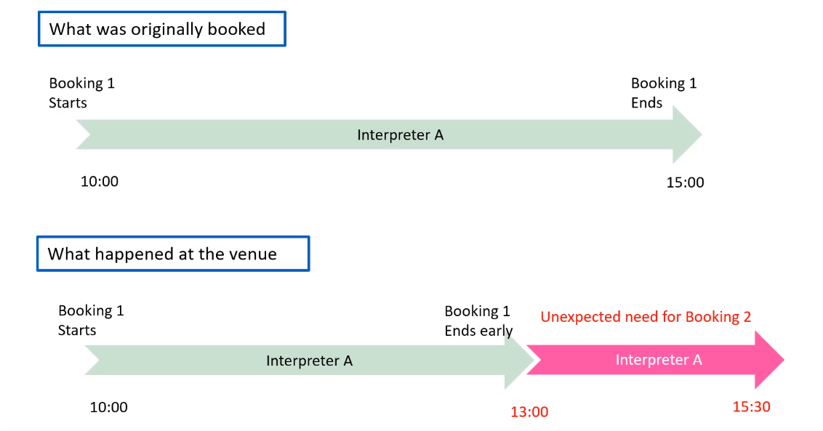
To allow you to become available for the new booking, you will need to submit the updated times/duration for the original booking in your app or on the portal. Until this is done, we will be unable to assign you to the booking:
- Navigate to the relevant booking number in the app or on the portal
- Click on “add duration”
- Update the times/duration for the booking

Accepting a booking during a lunch break
If you are asked to accept a new booking during your lunch break, there will be a conflict recorded in our systems and you will be unavailable to accept the booking:
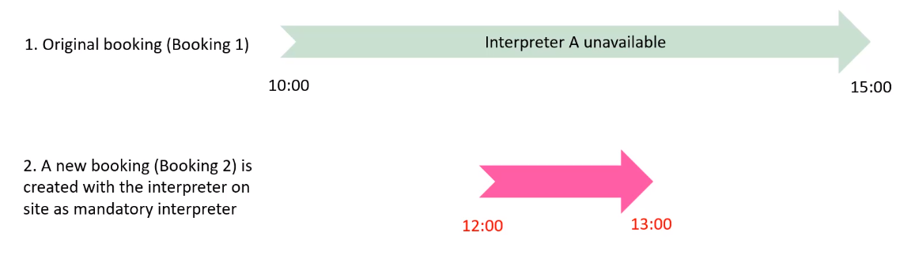
To update your availability, you can now submit lunchbreak times as follows:
- Navigate to the relevant booking in your app or on the web portal
- Click on “add duration”
- Update your lunch break duration in the “Lunch Break Information” section
- Click on “Save Lunch Break Times”
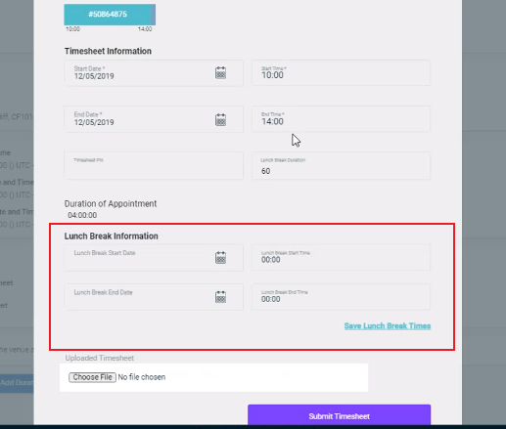
This will allow you to update your lunch break times without needing to submit the final times for the booking; your availability will update and it will become possible for the helpdesk team to add you to the booking.
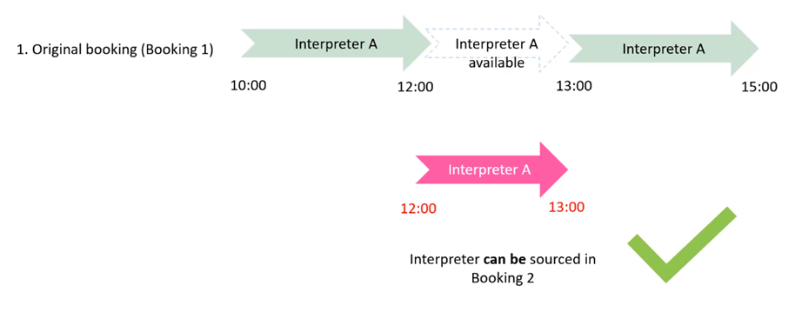

Adding durations in booking order
It is common for interpreters to accept multiple bookings in a day and for those booking times to alter dynamically as the day progresses, with some ending early and others overrunning:
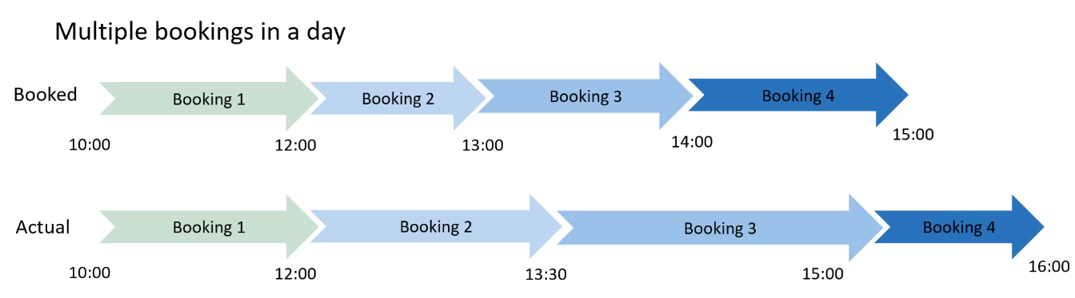
To ensure that all times are added correctly with no overlaps, you will now be required to add your times in the order in which bookings were completed (e.g. booking 1, then booking 2, followed by bookings 3 & 4)
- When you navigate to add your timesheet and booking duration, you will be able to see all bookings attended on that day:
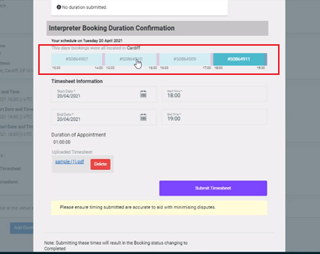
- You can move from booking to booking in this view by clicking on the relevant booking number

- If you try to add times for a later booking, you will get an error notification advising you that there are earlier bookings which need times to be added first:
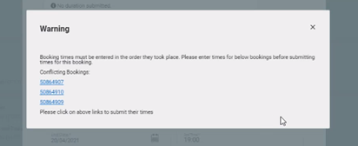
- You can click directly on the booking number links to be taken to the booking and submit the relevant times.

